

Emergency preparedness plan. WAC 110-300-0470, 0166

Table of contents
• Emergency preparedness (WAC 110-300-0470, 0166)
• Evacuation Plan: (WAC 110-300-0470)
• Fire Evacuation Plan: (WAC 110-300-0470)
• Earthquake Plan (WAC 110-300-0470)
• Floor Plan WAC 110-300-0400
• Lockdown Plan and Shelter in Place plan: (WAC 110-300-0470)
• Injury or medical emergency response and reporting (WAC 110-300-0475

Our emergency plan is designed to respond to fires, natural disasters, and other emergencies that might affect our program. We will follow all the requirements in chapter WAC 212-12 of the Fire marshal standards and the state fire marshal's office requirements. We will have all parents and staff read and sign that they have received and read this policy. We will train all staff when hired and yearly thereafter on this plan. We will provide additional training if the plan is changed and provide a copy of the new plan to the Department and the families. We will keep a copy of this plan state where this policy will be kept and if it accessible electronically. In the case of a disaster of any kind, I have prepared my home for evacuating the children and have a three-day supply of food and water for each child, family member and staff. I have required parents to bring a three-day supply of any required medications for their child/children. We have prepared our home to be able to keep the children at our facility until the parents are able to safely arrive to pick up their children after a disaster, and will not leave your child unsupervised, will not be out of ratio and will work with the local authorities to access our home or to evacuate to a safe location. We have informed each parent of our out of state contact, our emergency evacuation locations and given them our contact information. All emergency drills will be recorded and posted on the bulletin board. The log includes the following:
(i) The date and time of the drill;
(ii) The number of children and staff who participated;
(iii) The length of the drill; and
(iv) Notes about how the drill went and how it may be improved.

Emergency preparedness (WAC 110-300-0470, 0166)

You will find our programs evacuation plan posted on the bulletin board in the child care and on the child care website for electronic access. We will practice and document monthly fire drills, and every three months we will have an emergency/disaster drills, and lock down/shelter in place drill. Please refer to this policy and my posted evacuation plan for a full list of details, floor plan, and gathering place outside of my home so you are aware of our emergency and natural and unnatural disasters and evacuation procedures.
I have practiced turning off water, power and gas. Shelving, furniture and heavy objects on high shelves have been secured to protect against falling. I continually check my home for potential hazards on a regular basis.
Should my home become inhabitable in a disaster, the children and I will be located at 13225 21st Pl W Lynnwood, WA 98087.
My emergency preparedness includes developmentally appropriate training with the children on how to respond in an emergency such as calling 911 and when it is appropriate to evacuate WAC 110-300-0470(1)(c).
If there is natural or unnatural disaster, we have equipped our home with enough food and water to last for at least three days. We will have a cell phone, if the phones work, we will attempt to reach each parent or guardian throughout the disaster, and when it is safe. We have enough clothes and bedding to last for at least three days. We have asked the parents to supply medication and a small comfort kit for their children for such a disaster (extra blanket, warm socks, pants, long sleeve sweater and rain boots) These items will be stored in the closet in their individual bags.
I have an emergency disaster kit, that has enough water for three days crackers, gold fish, graham crackers, tuna fish, canned beans, canned mandarin oranges, canned peaches, canned green beans to last at lease three days. I have a battery operated flashlight with additional batteries and a back up battery for my cell phone.

Evacuation Plan: (WAC 110-300-0470)

When On-site:
• All children will be gathered and escorted to the designated meeting spot located: at the big tree in the front yard or at 13225 21st Pl W Lynnwood, WA 98087. This information is posted on the bulletin board in the childcare.
• If possible, the attendance sheet will be brought outside and a name to face check will be done.
• A head count of the children will be taken to ensure all children are present and adults will talk to children in a calm reassuring tone
• If safe to do so, the whole home will be checked, to ensure that all children have left the building safely.

When Off-site:
• All children will be gathered and escorted to the designated meeting spot with the grab and go bag and our daily attendance log, items in the grab and go bag are as follows: water, gold fish, graham crackers, tuna fish, canned beans, canned mandarin oranges, canned peaches, canned green beans to last at least three days.
• A head count of the children will be taken to ensure all children are present and adults will talk to children in a calm reassuring tone
• All areas will be searched (including bathrooms, playground structures, etc.), to ensure that all children are safe and accounted for
• Once out of danger, families will be contacted. If we are unable to make contact by phone, we will then call the identified out-of-area emergency contact or 911 to let them know of our location
• If an earthquake takes place while transporting children, we will remain in the car until it is deemed safe to get out.
We will practice evacuation drills monthly and all ages will be included in these drills as long as the child can walk independently.
Children who can not walk independently will be carried out of the childcare safely. Other children with disabilities, functional needs requirements or other special needs children will be hand walked out of the childcare or also carried out of the child care.

Fire Evacuation Plan: (WAC 110-300-0470)

To prevent fires, we complete monthly inspections of our Smoke detectors, alternate alarms and Emergency lighting; We practice monthly fire drills and have a smoke detector in each napping room and one on each floor of our home. We follow the state building code WAC 51-51-0314. We have and maintain a working fire extinguisher that is marked with a minimum rating of 2A:10 BC. Our extinguishers are located on each level of our home that is used by children and mounted within seventy-five feet of an exit on the path of the exit. Our extinguisher is located in the closet on the first level of the childcare and there is a sign on the front of the closet stating there is an extinguisher inside.

We will have either an announced or unannounced fire drill monthly that will include all children. Before and after school age children or children that come in the evening only, will practice fire drills at different times of the day so that those children will be included in the drill.
We will use a whistle (three blows) to activate the emergency action plan and sound the alarm.
In the event of a fire we will go to the back yard that has a gate so we can get out safely or we will go to 13225 21st Pl W Lynnwood, WA 98087.
We will follow the procedure below for our fire drills or if there is a real fire
• Before a child participates in a fire drill, unless there is a real fire or other emergency, we will discuss with the child the importance of drills. This will happen a day or two before a drill. We will discuss the expectation that children remain together, why we do drills, how we will sound an alarm and what the procedure will be.
• On the day of the drill we will activate our alarm system such as blowing the whistle( 3 blows) to alert children, staff and others who may be in the home that there is a fire.
• We will evacuate the building quickly and calmly:
• If anyone’s clothes catch on fire they will be instructed to STOP, DROP, & ROLL until the fire is out
• We will take our grab and go bag that includes cell phone, attendance sheets, first aid kit, medication and forms and emergency forms, which included the parent or guardians contact information as we are exiting the building if possible and all the food items and water mentioned above.
• We will check areas where children may be located before leaving the building
• During fire drills and other times that children need to be evacuated, I will be solely responsible for evacuating all children. If there is staff, volunteers or other adults at the child care during a drill or emergency I may assign tasks to them.
• Once everyone has evacuated the building safely a head count of the children will be taken to ensure all children are present and adults will talk to children in a calm reassuring tone
• We will remain within the regulated staff to child ratios throughout the drills and during a real disaster.
• We will use the fire extinguisher if the fire is small fire that can be put out in less then two minutes and only after the children have been evacuated.
• We will call 911 from outside of the building and will not re-enter the building until it has been cleared by the fire department.
• We will document the fire drill on the Department form and have the documentation posted on the bulletin board.

Our documentation will include:
(i) The date and time of the drill;
(ii) The number of children and staff who participated;
(iii) The length of the drill; and
(iv) Notes about how the drill went and how it may be improved
• We will contact the parents as soon as we can safely do so. Parents can call our emergency contact at (513) 628-2822 Tammie Dale. We will let the parents know where we will be located and when it would be safe to pick up their child.
• After a fire drill parents can review the fire and disaster drill log posted on the bulletin board.
We will report within twenty-four hours to the office of the state fire marshal any accidental or unintentional fire, any deliberately set improper fire, any unusual incident that required implementation of the facility disaster plan, including any evacuation of all or part of the resident population to another area within the facility or to another address. WAC 212-12-025

Earthquake Plan (WAC 110-300-0470)
We have worked hard to prepare our home to be safe during an earthquake. We have secured large items so that they will not fall during an earthquake, we have practiced shutting off our gas, electricity and water and have shut-off devices for them remove gas if you do not have gas and Secured our water heater(s) to walls. We have anchored bookcases and filing cabinets to walls and installed latches on drawers and cabinet doors that might be dangerous if they open up during earthquakes. We have place heavy items on lower shelves, and secured large, heavy items and breakables have been secured directly to shelves. We have attached computers and small appliances to desks, tables or countertops or moved them where they will not fall on children. We have secure ceiling lights, and other hanging items such as chandeliers and plants to the permanent structure of our home. Plants, radios and other items have been secured to the shelves. We have emergency earthquake drills once a quarter. Children in night time care and before and after school care will be included in the drills. We have earthquake drills every three months and document the drills on our log posted on the bulletin board.

When Indoors:
• We move away from windows, tall furniture, and heavy appliances
• Everyone in the program will be instructed to:
• DROP to floor
• COVER head and neck with arms and take cover under heavy furniture or against internal wall
• HOLD ON to furniture if under it until shaking stops
• A head count of the children will be taken to ensure all children are present and adults will talk to children in a calm reassuring tone until it is safe and the earthquake is over

When Outside:
• Move to clear area, as far as possible from glass, brick, and power lines.
• DROP & COVER.
• Adults will talk to children in a calm reassuring tone until it is safe and the earthquake is over
• A head count of the children will be taken to ensure all children are present
After earthquake:
• Account for all children, staff, and visitors
• Check for injuries and administer first aid as necessary. Call 911 for life-threatening emergency
• Determine if evacuation is necessary and if outside areas are safe. If so, we will evacuate building calmly and quickly to our designated meeting spot located: state your off-site meeting area
• We will coordinate with local or state officials to determine if the licensed space is safe for children after an earthquake by calling 911 or the broadcasted emergency number.

If gas is smelled; the main gas valve will be immediately turned off
• We will monitor our portable radio or cell phone for information and emergency instructions
• Our designated out-of-area contact will be notified of our status when possible and if needed.
• We will remain outside of building until it has been inspected for re-entry and determined safe.

We will assess if the facility is safe to go back into by having a staff member check inside or the proper authorities have determined it to be safe to inhabit once again. Parents can contact Tammie Dale who lives in Ohio, she is my out of state contact in case of an emergency and her phone number is (513) 628-2822. We will practice earthquake drill once quarterly and the information will be posted on the bulletin board in the child care. If the childcare is determined to not be safe to re-enter then, we will go to 13225 21st Pl W Lynnwood, WA 98087.

Floor Plan WAC 110-300-0400

Add a page that includes your evacuation floor plan that identifies names of rooms, emergency exit pathways, emergency exit doors and emergency exit windows if applicable. Add to the floor plan where your smoke detectors, carbon monoxide detectors and fire extinguishers are located

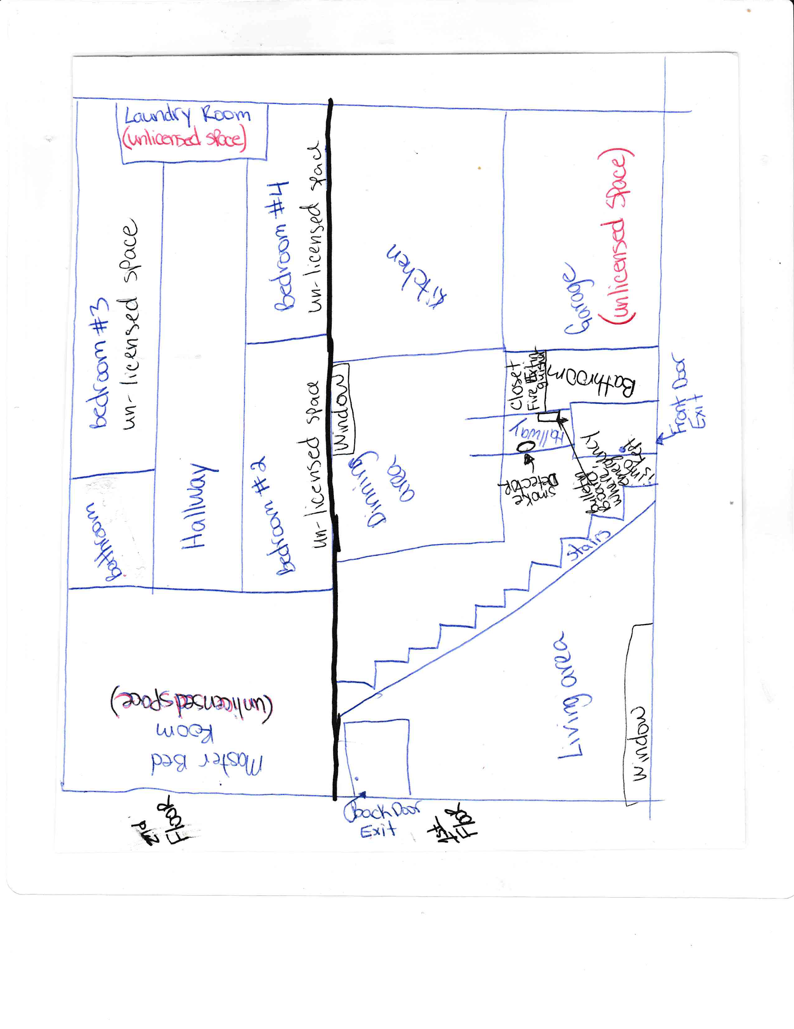

Lockdown Plan and Shelter in Place plan: (WAC 110-300-0470)

We have prepared our home for emergencies to keep it secured from any type of threat, such as when an individual at or near our home is harming or attempting to harm others with or without a weapon or other reasons that our home must be in lock down. We practice lockdown drills every three months. Children who are in care part time, overnight care, or before and after school children will also be included in these drills. The procedure that we follow for both a drill and an actual event is as follows:
• We lock all entrance and exit doors and windows, close and secure interior doors,
• Windows will be covered or made to not be able to be seen through, and all lights will be turned off. I will close all curtains.
• We will keep everyone away from doors and windows. Stay out of sight, preferably sitting on floor; I will gather all the children into the bathroom away from all windows.
• When possible, we will bring attendance sheets, first aid kits, pacifiers and other comforting items, and books to our safe lockdown area;
• To maintain a calm atmosphere in the room we will read or talk quietly to children;
• If a phone is available, we will call 911 to ensure emergency personnel have been notified;
• We will remain under lockdown until the situation is resolved or we are notified that it is safe to resume the daily routine;
• We keep on the premises a three-day supply of food, water, and life-sustaining medication for the licensed capacity of children, and our family for use in case of an emergency.
• We will notify parents and guardians about any lockdown, whether practice or real. If real we will notify parents and guardians when it is safe to do so.
• We will not be discussing weapons, shooters or other information about the reasons for a lockdown with the children and will be calling these types of drills the quiet hide and seek contest.

Injury or medical emergency response and reporting (WAC 110-300-0475)

1. I have First Aid, Child CPR, and HIV/Aids/Blood Borne Pathogens Prevention training.
2. Minor cuts, bruises, and scrapes will be treated. Parents will be notified with an injury report at the end of the day. With some minor injury’s parents may be called to help decide treatment for the child.
3. Head injuries, severe bleeding or other serious injuries we will contact the parent immediately and write an injury/incident report.
4. In the event of a serious injury or emergency, I will call 911 and administer first aid or CPR if needed. I will notify the parents as soon as safely possible.
5. If injury results in medical treatment or hospitalization, I will immediately call and submit an "Injury/Incident Report" to the Department’s Licensor and child’s social worker, if applicable. I will give a copy of these reports to the parents.
6. All injuries that the child arrives with will be documented and an injury/incident report will be written.

